Name: - Valle Ramesh
Difference between Vague Prompt vs Good Prompt
(i.) Vague Prompt
Prompt: - Information about stock market?
Result: -
The stock market is a marketplace where investors buy and sell ownership shares of publicly listed companies. It helps companies raise money and gives investors an opportunity to grow their wealth.
Key concepts
- Stock (Share): A unit of ownership in a company.
- Stock Exchange: A marketplace where stocks are traded, such as New York Stock Exchange (NYSE), NASDAQ, National Stock Exchange of India (NSE), and BSE.
- Investor: A person who buys stocks to earn returns over time.
- Trader: A person who buys and sells stocks frequently to profit from short-term price changes.
Ways to earn from stocks
- Capital appreciation: Selling a stock at a higher price than you bought it.
- Dividends: Some companies share a portion of their profits with shareholders.
Benefits
- Potential for long-term wealth creation.
- Ownership in successful companies.
- Diversification across different industries.
- Liquidity, as stocks can usually be bought and sold quickly during market hours.

Common investment strategies
- Long-term investing: Holding quality stocks for several years.
- Value investing: Buying undervalued companies.
- Growth investing: Investing in companies expected to grow rapidly.
- Dividend investing: Focusing on companies that pay regular dividends.
Example
Suppose you buy 10 shares of a company at ₹100 each. Your investment is ₹1,000.
- If the price rises to ₹120, your investment becomes ₹1,200, giving you a profit of ₹200 (excluding taxes and transaction costs).
- If the price falls to ₹90, your investment becomes ₹900, resulting in a loss of ₹100.

(II.) Good Prompt
Prompt: - Act as a stock market expert, provide detailed information about stock market like a beginner, as i want to invest in future. Explain graphs as well, like provided images completely. Give me entire answer, with bullet points for key points, tables for comparisons, with length less than 1000 words, in friendly manner.
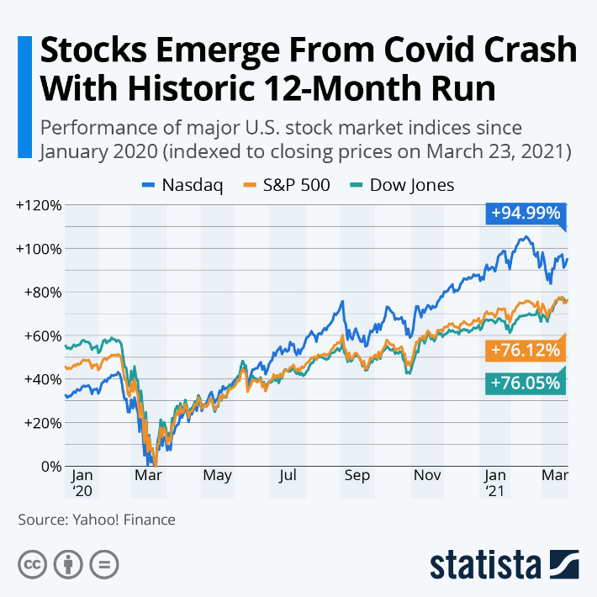

Result: -
Stock Market for Beginners
The stock market is a marketplace where investors buy and sell ownership (shares) of companies.
Example:
- Company: Apple
- You buy 10 shares.
- If Apple's business grows, its share price may increase.
- You can earn money through:
  - Capital Appreciation (share price increases)
  - Dividends (company shares part of its profit)

Basic Terms You Must Know
Term | Meaning | Example
Stock/Share | Small ownership in a company | 1 Apple share
Investor | Person buying shares | You
Stock Exchange | Place where stocks trade | NSE, BSE, NYSE, Nasdaq
Portfolio | Collection of investments | Apple + Microsoft + Tesla
Index | Group representing the market | Nifty 50, S&P 500
Bull Market | Prices rising | 2020–2021 recovery
Bear Market | Prices falling | COVID crash (March 2020)
Dividend | Profit paid to shareholders | Quarterly cash payment
Market Cap | Company value | Price × Total Shares

Understanding the Graph You Shared
What is this graph?
It shows how major U.S. stock market indices performed from January 2020 to March 2021, including the COVID-19 crash and recovery.
Lines
- 🔵 Nasdaq → Technology companies (Apple, Microsoft, Amazon, Nvidia, etc.)
- 🟠 S&P 500 → Top 500 large U.S. companies
- 🟢 Dow Jones → 30 large, established U.S. companies

X-Axis (Horizontal)
Shows Time
- Jan 2020
- Mar 2020
- May
- Jul
- Sep
- Nov
- Jan 2021
- Mar 2021

Y-Axis (Vertical)
Shows Percentage Gain/Loss
- 0% = Starting point
- +20% = Market gained 20%
- +50% = Market gained 50%
- +100% = Market doubled
The graph is indexed, meaning each index starts from the same baseline so you can compare performance fairly.

Step-by-Step Explanation
1. January–February 2020 (Before COVID)
- Market was healthy.
- Companies were growing.
- Investors were optimistic.
Result:
- All three indices were moving upward.

2. March 2020 (COVID Crash)
Suddenly:
- Lockdowns worldwide
- Businesses closed
- Travel stopped
- Fear in the market
Investors sold shares rapidly.
Result:
- All indices fell sharply.
- This is called a Bear Market.

3. April–June 2020 (Recovery Begins)
Governments and central banks:
- Reduced interest rates
- Provided stimulus packages
- Supported businesses
People started investing again.
Markets began recovering.

4. July–December 2020 (Strong Growth)
Technology companies benefited because:
- Work from home
- Online shopping
- Cloud computing
- Video meetings
- Digital entertainment
That's why Nasdaq grew much faster than the others.

5. January–March 2021
Markets continued rising with:
- Vaccine rollout
- Economic reopening
- Higher investor confidence
Final performance:
- Nasdaq: +94.99%
- S&P 500: +76.12%
- Dow Jones: +76.05%

Why Did Nasdaq Perform Better?
Nasdaq | S&P 500 | Dow Jones
Mostly technology companies | 500 companies from many sectors | 30 large traditional companies
High growth | Balanced growth | Stable companies
More volatile | Moderate volatility | Lower volatility
Highest return in this period | Strong return | Strong return

Key Lessons from This Graph
- Markets can crash unexpectedly.
- Panic selling often locks in losses.
- Long-term investors may benefit from staying invested.
- Technology can outperform during certain economic periods.
- Diversification helps reduce risk.

Types of Investors
Type | Holding Period
Day Trader | Minutes to hours
Swing Trader | Days to weeks
Position Trader | Weeks to months
Long-Term Investor | Years to decades
For beginners, long-term investing is generally simpler and less stressful than frequent trading.

Beginner Investment Strategy
- Learn before investing.
- Build an emergency fund first.
- Start with index funds or ETFs for diversification.
- Invest regularly (monthly SIP or recurring investment).
- Diversify across sectors and companies.
- Reinvest dividends when possible.
- Avoid investing based on rumors or social media hype.
- Review your portfolio periodically instead of daily.

Common Mistakes Beginners Make
❌ Investing without research
❌ Following tips blindly
❌ Panic selling during market crashes
❌ Putting all money into one stock
❌ Trying to get rich quickly
❌ Using borrowed money to invest

How to Analyze a Stock
Factor | What to Check
Business | What does the company sell?
Revenue | Is sales growth consistent?
Profit | Is the company earning profits?
Debt | Is debt manageable?
Management | Is leadership trustworthy?
Valuation | Is the stock reasonably priced?

Golden Rules for Beginners
- 📈 Invest for the long term (5–10+ years).
- 💰 Only invest money you won't need soon.
- 📚 Keep learning about markets and businesses.
- 🌍 Diversify instead of relying on a single stock.
- ⏳ Time in the market is usually more important than trying to perfectly time the market.
TASK – 2 (E-MAIL Replay)
"I've been waiting two weeks for my refund and nobody has responded to my last three emails. This is ridiculous—I want my money back now."
Vauge Prompt: - Replay to this mail
Dear Customer,
Thank you for reaching out, and I sincerely apologize for the frustration and inconvenience you've experienced.
I'm sorry that you've had to wait two weeks for your refund and that your previous emails went unanswered. I completely understand how disappointing this must be.
We are currently reviewing your refund request as a priority. Our team will verify the details and provide you with an update as soon as possible. If your refund is approved, it will be processed promptly, and we'll keep you informed throughout the process.
We truly appreciate your patience, and we're committed to resolving this matter as quickly as we can. If you have any additional information, such as your order number or transaction ID, please reply to this email so we can expedite the investigation.
Again, we sincerely apologize for the delay and appreciate the opportunity to make this right.
Kind regards,
Customer Support Team
Good Prompt: -
Act as a customer support executive, replay to this mail from a customer, who already sent three mails and waiting for his refund amount from last two weeks. Email format should be, subject, greetings to customer, body, thanking the customer for approaching. Don't mention the clear date or time, as we have no update regarding date of refund. Be Polite and content should be under 200 words, maintain content in professional way.
Output: -

Subject: Re: Refund Request – Update on Your Case
Dear Customer,
Thank you for reaching out, and we sincerely apologize for the delay in responding to your previous emails as well as the inconvenience caused by the pending refund.
We completely understand your frustration and appreciate your patience. Please be assured that your refund request is currently under review with the relevant team. While we do not have an update to share at this time, we are actively following up to ensure your request is processed as soon as possible.
We understand how important this matter is, and we appreciate your continued patience while we work toward a resolution. As soon as there is any progress regarding your refund, we will notify you promptly.
Thank you for giving us the opportunity to assist you. If you have any additional questions or require further assistance, please feel free to reply to this email.
Kind regards,
Customer Support Team

